Bandit level 13 to level 14
To login to the level 13 use the username as
And then use the command dir is to show the list of files
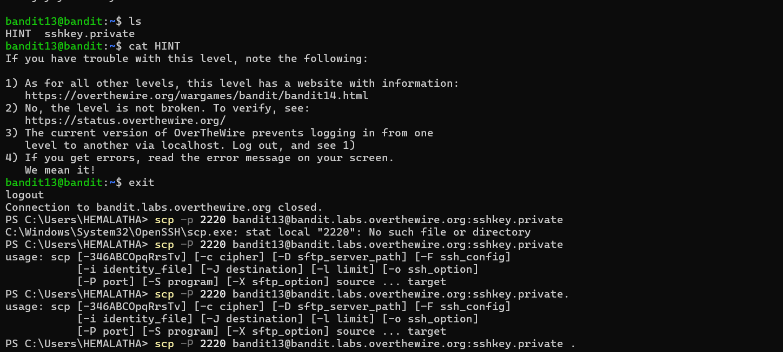
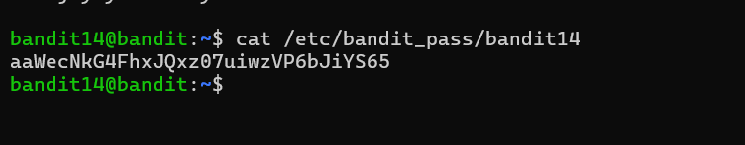
Finally we will get the output for it for the next level 14 and 15

